Crime Risk Prediction Using Machine Learning

DL - MINI PROJECT REPORT

Submitted by

VINAYAK JOLLY (24MCI10064)
VISHVAM PARIHAR (24MCI10010)

in partial fulfillment for the award of the degree of
MASTER OF COMPUTER APPLICATIONS

IN

COMPUTER APPLICATIONS


Chandigarh University, India.

November, 2025



CERTIFICATE OF ACCEPTANCE

Certified that this project report “Crime Risk Prediction Using Machine Learning” is the bonafide work of “VINAYAK JOLLY and VISHVAM PARIHAR” who carried out the project work under my/our supervision.
This project work is hereby accepted by the Department of Computer Applications, University Institute of Computing, Chandigarh University, India, in partial fulfillment of the requirements for the award of Degree in Master of Computer Application.

SIGNATURE
Dr. Disha Handa
SUPERVISOR

ACKNOWLEDGEMENT

We would like to express my heartfelt gratitude to all those who assisted us in preparing and completing our Major Project report titled "Crime Risk Prediction Using Machine Learning" We extend my sincere appreciation and thanks to Dr. Sumit Kushwaha for inspiring, cooperating, and encouraging us to pursue my work.
With his valuable suggestions and guidance, We were able to complete my work in a short time frame at this institution.
We also convey our respect and gratitude to Dr. Krishan Tuli, (HOD) University Institute of Computing, and Chandigarh University, as well as all the faculty members, for their valuable suggestions and guidance towards completing the report.
Furthermore, We are grateful to all our academic mentors who provided direct or indirect assistance in successfully completing our major project report.
Last but not least, we are immensely grateful to our parents, who served as a constant source of encouragement and inspiration throughout the completion of this work at Chandigarh University, Mohali.

Vinayak Jolly (24MCI10064)
Vishvam Parihar (24MCI10010)

ABSTRACT

Ensuring public security and reducing criminal activity remain significant issues within contemporary metropolises. The initiative introduces an integrated machine learning framework aimed at forecasting criminal activity risks by analyzing contextual and chronological variables. This study analyzes data from India's criminal records using various machine learning algorithms. It specifically examines how well each model performs in distinguishing between crimes based on features like location and time. Among these, Random Forest stands out due to its strong predictive capabilities and ease of understanding by humans. The highly refined Random Forest algorithm serves as the core of our system, which operates via a Python-based Flask framework behind-the-scenes and presents user interfaces through static HTML pages accompanied by CSS styling and JavaScript functionality on top-level components. This instrument offers instantaneous security evaluations through analysis of crucial elements like Location, Incident Details, Calendar Date, Time Period, and Specific Hours. This system showcases an effective use of artificial intelligence techniques to improve public safety by increasing citizen surveillance capabilities and possibly assisting police departments in managing resources efficiently.

CHAPTER 1
INTRODUCTION

1.1 Project Scope and Planning
Today's hectic environment emphasizes the heightened importance of individual protection and tranquility. During periods marked by swift city growth in modern times, numerous Indian metropolises confront intricate issues related to controlling criminal activities effectively. Policing practices frequently focus on reacting rather than preventing issues when problems arise. With the emergence of data science and machine learning, there's an exciting chance for moving toward a forward-looking and forecasting-driven approach.
Key Highlights:
- The Crime Zone Risk Prediction tool employs user-centric principles, offering a straightforward interface that enhances usability across various demographics. A highly refined design ensures smooth input for users, enabling them to quickly choose their location, incident category, day of occurrence, and specific hour without difficulty.
- Our software relies on an AI algorithm developed using extensive datasets comprising criminal records across multiple Indian towns for its functionality. It guarantees that forecasts rely exclusively upon discernible trends derived from actual events data analysis rather than conjecture.
Objectives:
- Conduct exploratory data analysis of the given Indian crime dataset in order to comprehend its characteristics and structures.
- Preprocess and engineer the dataset by addressing categorial information such as City and Crime Type along with incorporating time-related attributes like Hour, Day of Week, and Month.
- Develop several machine learning algorithms, assess their performance on identifying high versus low risks accurately and stably, then select the most effective model among them.
- Choose the most efficient model (Random Forest), then store both this selection along with any necessary data transformations used during training, ready for application in production environments.

1.2 Client Identification and Recognition of Need
Recognizing the client and acknowledging the need for a crime prediction project are important first steps in appreciating what the project is intended to accomplish, who will use it, and what it needs to do.
Client Recognition and Identification
The intended clients or end-users for the "Crime Zone Risk Prediction" application are varied:
- The General Public: Someone who is traveling, commuting or a student or tourist, who wants to assess an area’s safety before visiting. This would include solo travelers, someone going home late at night from work or a parent wanting to take their children on an excursion. The app allows potential visitors to make informed decisions about when and how to get to a destination.
- Law Enforcement: Police departments and security companies may use this tool as an additional data point when determining resource allocations. It is not meant to replace policing but may provide additional insights for when and where to direct additional patrols or resources, potentially flagging potential high-disruption time periods or areas for concern before they occur.
1.3 Task Identification
Identifying tasks for a crime prediction app is about breaking the project down into discrete tasks that you need to execute in order to achieve the goals of the project.
- Project planning and set up:
Identify the project's scope and objectives (binary risk) and requirements. Set up development environment (e.g., Python, Flask) and version control capabilities.

- Data gathering and research: Gather and integrate the crime_dataset_with_risk.csv file. Look at what other crime prediction projects exist in order to identify the features it might have, and pitfalls to avoid.
- Data Preprocessing and Feature Engineering:
- Load data into a Pandas DataFrame.
- Handle missing values .
- Engineer new features – e.g., DayOfWeek, Month, Hour.
- Encode categorical features using LabelEncoder: QCity, Crime_Description, DayOfWeek.
- Define the binary target variable Risk
- Split the data into training and testing sets;
- Model Training and Evaluation:
  - Train several candidate models – XGBoost and Random Forest.
  - Evaluate models by Accuracy, Precision, Recall, F1-Score
  - Develop the Confusion Matrix for the Random Forest model.
  - Select the Random Forest model.
  - Save the trained model random_forest_model.pkl and the LabelEncoders via joblib label_encoders.pkl
- Back-end Programming:
    - Create a Flask server (app.py).
    - Build the homepage route (/) to render your html page.
    - Create the route to 'predict' (/predict) to accept POST requests.
    - Implement the logic to 'predict': load the data, apply encoders, run
    - model.predict().
    - Build the 'reasoning' logic that will provide context to the user.

- Front-end Programming:
- Develop a simple, intuitive UI with index.html.
- Design form elements for all 5 features (dropdowns, number input).
- Style the page with style.css for a professional appearance.
- Implement JavaScript for dynamic functionality (i.e., updating the
background image based on the city).
- Integration and Testing:
- Link the Flask API on the backend to the frontend form.
- Conduct end-to-end testing by completing the form, clicking submit, and
confirming that the right prediction and justification are shown.
- Examine edge cases, such as missing inputs and unseen labels.
- Implementation:
- (Future Scope) To make the application publicly available, deploy it to a cloud platform such as Heroku or AWS.

1.5 Technologies Used
The system employs a collection of contemporary, open-source technologies focusing on Python for data science and web applications.
- Front-end Technologies: The client side is built using:
    - HTML5: Used for the skeleton structure of the web page and the prediction form.
    - CSS3: Used for all styles including layout, colors, fonts, and the background overlay (style.css).
    - JavaScript: Used for client-side interaction, specifically the capability to change the background image based on the selected city.
- Back-end Technologies: The server side is implemented using:
    - Python: The core language used for both the machine learning model and the web application server.
    - Flask: A light and flexible Python web framework used to build the web application server (app.py). It is used for routing (to serve the HTML page), and API endpoint (/predict) to receive user data and return prediction data.
1.6 Timeline of The Project .
- PHASE 1: Pre-Development (Research & Planning): The first phase consisted of defining the problem statement, researching existing crime prediction systems, identifying the aims of the project, and obtaining the first dataset.
- PHASE 2: Design and Prototyping (Data Analysis): In this phase, we explored data analysis (EDA). We specifically explored the dataset to identify features of interest, make distributions of the data visible, and prepare a feature engineering scheme. The EDA was accompanied by initial wireframes for the web application user interface (UI).
- PHASE 3: Development (Model Training & Backend): The central technical phase. This is where we pre-processed the data, trained and compared models ( XGBoost and Random Forest), and chose the final model (Random Forest). (Flask) backend (app.py) was developed alongside.
- PHASE 4: Testing and Quality Assurance (Frontend & Integration): In this phase, we developed the index.html and style.css files, then integrated the frontend with the backend (API). We rigorously tested the encoders, ensuring that they worked and that the predictions were quick and accurate.
- PHASE 5: Deployment and Launch: The application was deployed locally. This phase corresponds to the creation of a final prototype that operates and can be demonstrated and used.

CHAPTER 2
DESIGN FLOW/PROCESS
2.1 Dataset and Feature Engineering
This project is based on a dataset of historical crimes (crime_dataset_with_risk.csv) from various cities in India. The process for building this was initiated with the selection of the most predictive features.
Evaluation & Selection of Features:
The raw dataset contained several columns. By applying EDA and correlation analysis, we found a subset of the features that will provide the most predictive power for a real-time user query by excluding features that would normally not be known to a user-such as "Case Closed"-or features that would otherwise create heavy bias-such as "Victim Gender."
The final selected features for the model are:
• City: a categorical variable that designates a crime's area of occurrence, such as "Delhi", "Mumbai".
• Crime_Description: The categorical feature representing the class of the crime; for instance, "ASSAULT", "ROBBERY".
• Day of Week: Temporal feature derived from date, for instance "Monday", "Sunday".
• Month: Temporal feature, 1-12, representing the time of the year.
• Hour: Temporal feature representing time of the day from 0-23.
Target Variable:
The target variable for our prediction is Risk. Based on the analysis, this was converted into a binary classification task:
- 0: Low Risk
- 1: High Risk
Feature Engineering & Preprocessing:
This was a critical step to convert the raw, mixed-type data into a fully numerical format suitable for the Random Forest model.
- Temporal Feature Extraction: The original dataset's timestamp was used to extract three separate numerical features: Hour, DayOfWeek, and Month. This allows the model to learn time-based patterns (e.g., "risk is higher on Friday nights" or "risk is lower in February").
- Categorical Encoding: The three categorical columns (City, Crime_Description, DayOfWeek) were converted to numbers using sklearn.preprocessing.LabelEncoder.
- Saving Encoders: It is essential that the live application uses the exact same numerical mapping as the training process (e.g., if "Delhi" was mapped to 4 during training, it must be 4 during prediction). To ensure this, we saved all fitted LabelEncoder objects into a single label_encoders.pkl file using joblib. The Flask application loads this file to transform live user input.

Features Selection-
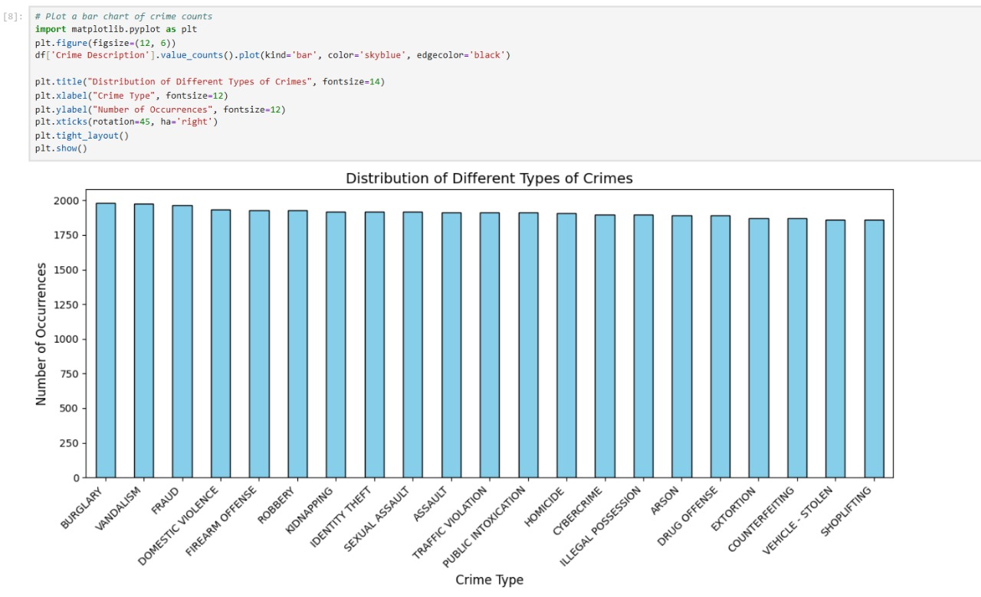
Random Forest Classification Report-
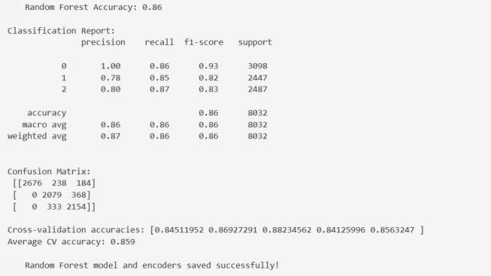
XGBoost Classification Report- 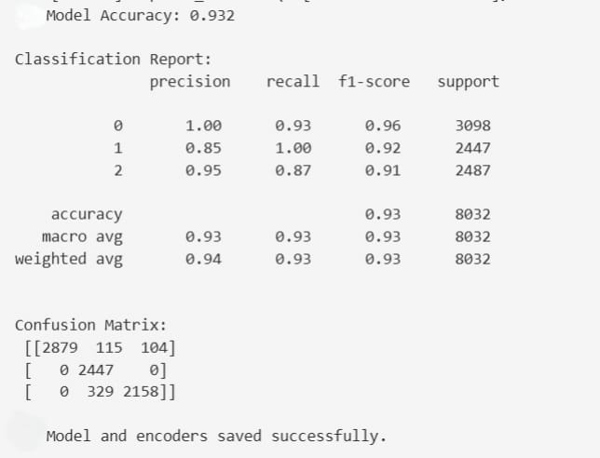

2.2 Model Selection and Training
Multiple models were trained and tested to come up with the best candidate for deployment. The main candidates considered were:
1. Artificial Neural Network: A deep learning model with sequential architecture. Although powerful, ANNs can be prone to overfitting on tabular data, careful tuning, and computational expense.
2. XGBoost (Extreme Gradient Boosting): An optimized tree-based ensemble model that has gained great acclaim for its accuracy and speed.
3. Random Forest: It is an ensemble that creates multiple decision trees and combines the outputs. It is robust, deals with tabular data well, avoids overfitting as much as a single decision tree might be prone to, and gives good performance without much tuning.

CHAPTER 3
TECHNICAL PERFORMANCE
3.1 Technology Roadmap
Creating a technology roadmap for the Crime Zone Risk Prediction application really comes down to deciding on key milestones, technologies, and strategies to produce and publish a successful app.
- Set the following goals and objectives below:

- Main objective: Create an intuitive web application that offers real-time, predictive crime risk assessments (High/Low) for Indian cities.
- KPIs: Use user task completion rate, server response time (<500ms), and prediction accuracy (target >85%) to gauge success.

- Market Research and Analysis:
  - Platform: Web-based application (desktop and mobile responsive) to ensure maximum accessibility without requiring a download.
  - Tech Stack:
    - Frontend: HTML/CSS/JavaScript (for simplicity and universality).
    - Backend: Python + Flask (ideal for ML integration).
    - ML Model: Scikit-learn (Pandas, RandomForest, Joblib).
- Designing User Interfaces (UI) and User Experiences (UX):

  - Create an interface that is easy to use and intuitive, with guided inputs that are clear (dropdowns are preferred over free text to prevent errors).
  - Conduct usability testing to gather feedback and iterate.

- Integration of Core Services:
  - Integrate the Scikit-learn model with the Flask backend using joblib for loading.
  - Ensure the LabelEncoders are correctly integrated to handle data transformation between the frontend (text) and the model (numbers).
- Quality Assurance and Testing:

- Unit Testing: (Future Scope) Write pytest for Flask predict function to validate logic.
- Functional Testing: Perform manual testing of all combinations of forms and edge cases (e.g. hour = first / last entries and all cities).
- Performance Testing: (Future Scope) Leverage locust or other similar application to create user scenarios to test 100s of concurrent users and server response time.
- Beta Testing: Deploy the project into the app and have a small group of users use the app to identify bugs.

3.2 Scalability Planning for Future Growth
Scalability planning is essential to ensure that the "Crime Zone Risk Prediction" application can handle future growth in user base and interaction volume without compromising performance.
- Architecture Design:
  - Current: The current single-file Flask app is a monolith.
  - Future: We can refactor this into a microservices architecture as the application expands. The "Prediction" service could be a self-contained API, which allows it to independently grow from the main web-serving application. The default Flask server cannot handle simultaneous requests, which is why we would want to run Gunicorn or some other production server with multiple worker processes.
- Cloud Infrastructure:
    - Current: The application is running on localhost.
    - Future: - Future: We will deploy on a cloud service, such as Heroku or AWS Elastic Beanstalk. These platforms have critical scaling features:
      - Auto-scaling: When CPU usage is high (e.g., a lot of users are requesting predictions), this automatically adds new server instances. After usage drops, it removes the additional server instances.
      - Load balancing: This distributes incoming traffic to multiple server instances, ensuring one server is not a bottleneck in those incoming requests.
- Database Scalability:
- Current: The project is "stateless" and runs no database. The "database" in this case is a set of .pkl files.
- Future: If we have user accounts in Phase 2, we will need a database. The standard recommendation is to manage a NoSQL or SQL database (such as Amazon RDS or DynamoDB)

- Caching and Content Delivery Networks (CDNs):
- Current: all static files (style.css, background image) are being served directly by Flask, with vast inefficiencies.
- Future: we would serve all static assets via a CDN (i.e., Amazon S3 + CloudFront), which serves files to a user from an ""edge location"" closer to their location, which reduces latency. We could also use a Redis cache to hold predictions for relatively common requests (i.e., "Delhi, HOMICIDE, Friday, 8 PM"). Assuming we get 1000 requests for this one prediction, we would only run the model once, and serving the cached prediction for 999 requests, substantially reducing our compute demands on the server.

CHAPTER 4
CONCLUSION AND FUTURE SCOPE

4.1 Conclusion
This project successfully developed and deployed a functional machine learning system for predicting crime risk in India. A Random Forest model was trained on a labeled dataset and demonstrated robust accuracy (86%) in its binary classification task. The model proved effective in identifying patterns across temporal and location-based features to distinguish between "High Risk" and "Low Risk" scenarios.
4.2 Future Planning (Future Scope)
While the project met its core objectives, its functionality could be significantly expanded in several ways:
- Expand the Dataset:
  - More Data: Incorporate data from a wider range of cities and time periods to improve model generalization.
  - More Features: Add more granular data, such as specific neighborhoods or postal codes (instead of just "City"), and environmental data (e.g., weather, public holidays, local events) to capture more complex patterns.
- Advanced Model and Feature Engineering:
  - Experiment with more advanced models (like Gradient Boosting Machines or deep learning) on the expanded dataset.
  - Implement more complex feature engineering, such as interaction features (e.g., "Time of Day" + "City").
- Automated Retraining Pipeline:
  - The current model is static. A key future step is to build a data pipeline (e.g., using Apache Airflow or AWS Lambda) that automatically pulls new crime data monthly, retrains the model, and deploys the new model file with zero downtime. This ensures the app's predictions never become stale.
- Cloud Deployment and Scalability:
  - Host the entire application on a cloud platform (like AWS or Heroku) to make it publicly and reliably accessible, as detailed in the scalability plan.

4.3 Output (Application GUI)
The frontend user interface (index.html) is the primary point of interaction for the user. It was designed to be clean, simple, and mobile-responsive.
The interface consists of a single container with a clear heading. It presents the user with a form containing five inputs, which directly correspond to the features required by the Random Forest model:
- City: A dropdown menu (<select>) listing all cities the model was trained on.
- Crime Description: A dropdown menu (<select>) for the type of crime.
- Day of Week: A dropdown menu (<select>).
- Month: A dropdown menu (<select>) for the month (1-12).
- Hour: A number input (<input type="number">) constrained from 0 to 23.

REFERENCES

- Pedregosa, F. et al. (2011). Scikit-learn: Machine Learning in Python. Journal of Machine Learning Research, 12, 2825-2830.
- Grinberg, M. (2018). Flask Web Development: Developing Web Applications with Python. O'Reilly Media.
- McKinney, W. (2010). Data Structures for Statistical Computing in Python. Proceedings of the 9th Python in Science Conference, 445, 51-56.
- Breiman, L. (2001). Random Forests. Machine Learning, 45(1), 5-32.
- Flask Documentation (2025). Retrieved from https://flask.palletsprojects.com/
- Pandas Documentation (2025). Retrieved from https://pandas.pydata.org/pandas-docs/stable/
- HTML5 Living Standard (2025). Retrieved from https://html.spec.whatwg.org/
- CSS Cascading Style Sheets (2025). Mozilla Developer Network. Retrieved from https://developer.mozilla.org/en-US/docs/Web/CSS

UI Interface –

